Color sensor application in high-temperature spectral ratio pyrometer
A A Valke, D G Lobov and A G Shkaev

Omsk state technical university (OmSTU) Mira pr., 11, Omsk, 644050, Russian Federation.

Abstract. Contactless thermal control tools play an important role in solving the high-temperature technological processes improving energy efficiency problems. In order to create such controls, the authors analyzed the developing possibility of spectral ratio high-temperature pyrometer using a multispectral radiation receiver (color sensor) TCS34725. In the paper this receiver application coefficients are determined, signals ratio graphs in different spectral intervals on temperature are given for two applications: without additional filtration of the control object radiation infrared component and using an opaque in the infrared spectrum part external filter.
1. Introduction
Currently, there are many technological processes with operating temperature ranges from 1000 to 3000 ° C. The such processes energy efficiency improving is an urgent task today, since this leads to significant savings in energy resources while reducing of the harmful impact relevant productions on the environment.
Such technological processes are found in the metallurgical industry, in the non-combustible thermal insulation production [1] and in carbon black production [2]. Contactless temperature control methods using pyrometers play an important role in solving the problems of the high-temperature technological processes energy efficiency increasing.
2. Problem statement
Two main pyrometers’ types are used to measure high temperatures: brightness (or radiation) and colour (or spectral ratio pyrometers). Radiation pyrometers are based on the object radiation energy brightness dependence in a limited wavelength range on its temperature. The spectral ratio pyrometers operation principle is to determine the temperature relative to the signals from several receivers operating in different spectral ranges.
The spectral ratio pyrometers application is preferable in some cases, since the readings of such devices are least affected by viewing windows contamination and by control object viewing channels partial dusting [3-6].
Currently, there are a large number of spectral ratio pyrometers used in production. Such devices include, for example, "Thermokont-TC5P", "S-3000.1 "Steel"", "Raytek MR1S" and others. The main spectral ratio pyrometers disadvantage is the high (hundreds of thousands rubles) cost, a significant part of which is the multispectral radiation receiver (RR) cost.
The article considers the low-cost spectral ratio pyrometer creating possibility, which uses an inexpensive TCS34725 type multispectral radiation receiver (color sensor) the manufactured by AMS-TAOS USA Inc. (USA) [7-9].
3. Theory
It is known that physical bodies with temperatures above absolute zero emit radiant energy in the electromagnetic waves form. At the same time, the radiation power from a surface unit and the radiation spectrum depend on the body temperature. The electromagnetic radiation spectrum for a perfectly black body (PBB) is described by Planck's law:
, (1)
where W_{λ} is the flow spectral density, C₁ and C₂ are constants, λ is the wavelength, T is the body temperature.
; (2)
, (3)
where c is the speed of light in vacuum, h is Planck's constant, k is Boltzmann's constant.
The graphs in Figure 1 show the change in the PBB radiative flux relative spectral density W_{λ} for different temperatures.

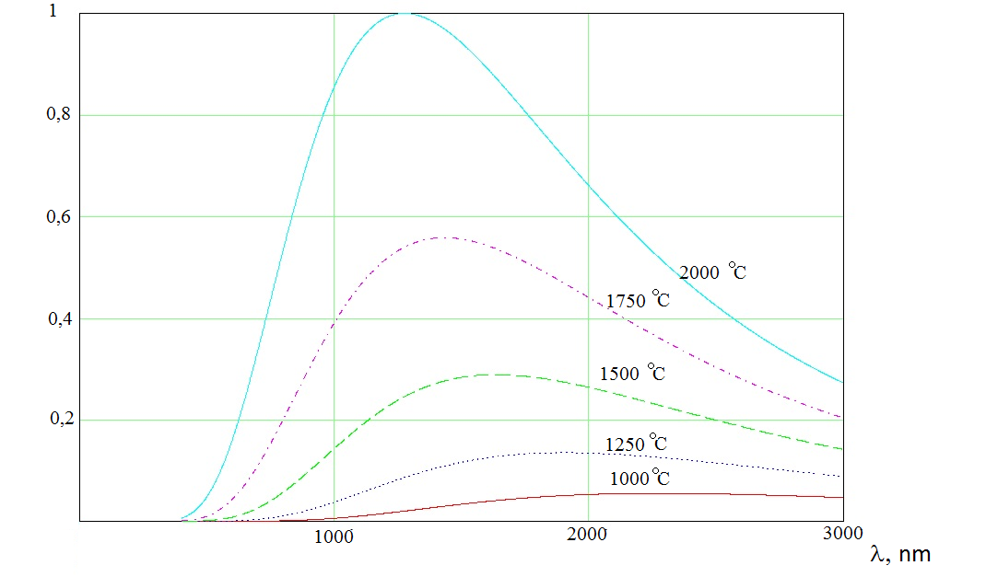
Figure 1. Change of PBB radiative flux relative spectral density W_{λ} for different temperatures.

Figure 1 shows that the Planck function maximum in the temperature range from 1200 to
2000 ° C is in the wavelength range of 1-2 microns. At the same time, when the temperature rises, the maximum shifts to the shorter-wavelength part of the spectrum. Accordingly, the radiation receiver should work in this spectrum part. The TCS34725 color sensor normalized spectral characteristic is shown in Figure 2. [10]
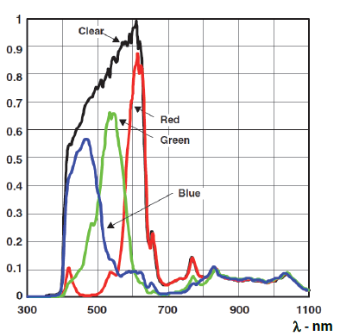
Figure 2. TCS34725 color sensor normalized spectral characteristic.

Figure 2 shows that the R-channel maximum spectral characteristic is at 615 nm, the
G-channel maximum spectral characteristic is at 525 nm, and the B-channel maximum spectral characteristic is at 465 nm. During the research, the TCS34725 color sensor use possibility as a radiation receiver for measuring temperatures in the range from 1200 to 2100 ° C was considered. This temperature range is typical for the carbon black production technological process.
4. Experimental results
During the research, the radiation receivers use coefficients for each of the three TCS34725 color sensor channels were calculated first, for 1200 ° C and 2100 ° C temperatures.
The use factor is determined by the dependence [4]:
(4)
where Φ(λ) is a function describing the distribution of the flow from the wavelength falling on the RR at a given controlled surface temperature; S(λ) is the RR sensitivity spectral characteristic. Thus, this coefficient shows what radiative flux proportion falling on the RR corresponds to its spectral sensitivity, and, therefore, is converted into an output signal.
In this case, the function Φ (λ) for the given temperatures was calculated in accordance with Planck's law, and the spectral characteristics functions S(λ) of the radiation receivers R-, G-, and B-channels were determined by the normalized spectral characteristics spline interpolation shown in Figure 2.
The use factor calculated values for different channels for temperatures of 1200 °C and
2100 ° C are shown in Table 1.
In contradistinction from a brightness pyrometer, a spectral ratio pyrometer determines the object temperature with respect to signals from several receivers operating in different spectral ranges. Therefore, the signals ratio from channels R, G and B was calculated in the measured temperatures range from 1200 to 2100 °C.

Table 1. Use coefficients.
Channel | Temperature
 | 1200 °С | 2100 °С
R | 0.073 | 0.1
G | 0.067 | 0.085
B | 0.066 | 0.07

Figures 3 and 4 show the signals ratio dependence of channels G and R, and channels B and R on temperature without using an external additional filter.

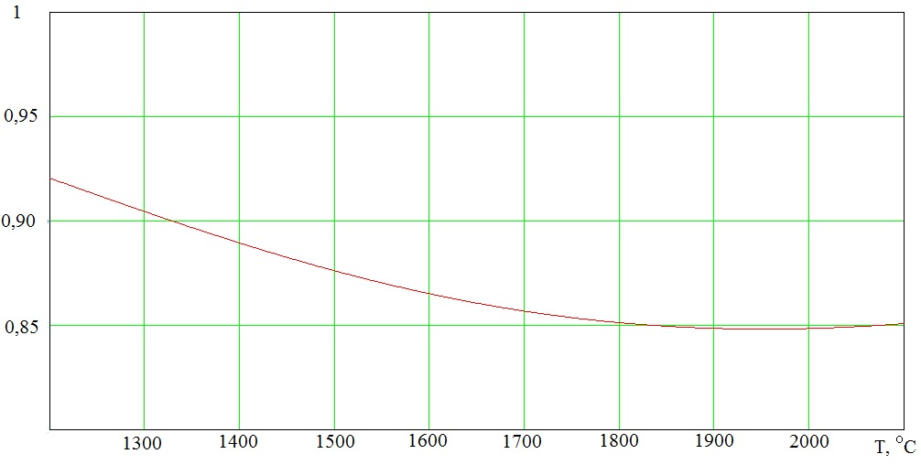
Figure 3. The signals ratio dependence of channels G and R on temperature without using a filter.

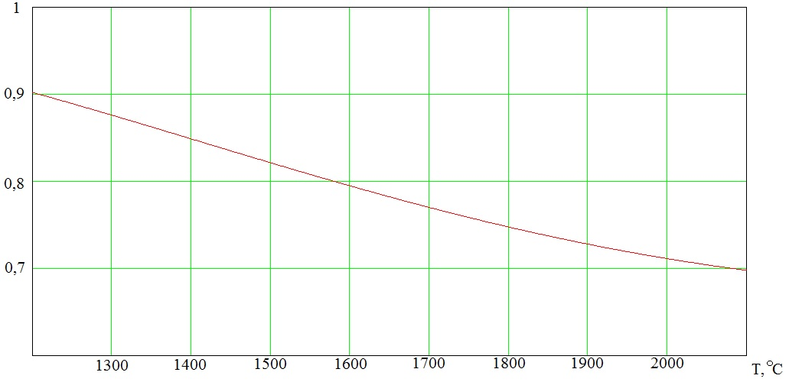
Figure 4. The signals ratio dependence of channels B and R on temperature without using a filter.

Figures 5 and 6 show the signals ratio dependence of channels G and R, and channels B and R on temperature using an external filter that cuts off the infrared spectrum part at a wavelength of
700 nm.

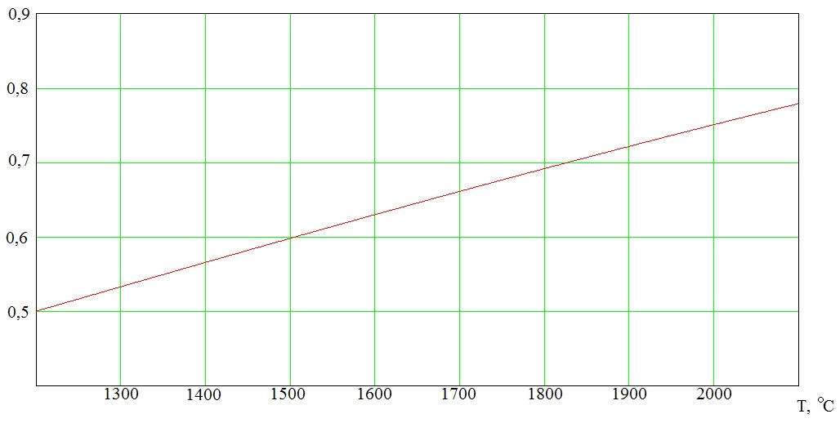
Figure 5. The signals ratio dependence of channels G and R on the temperature with the filter.

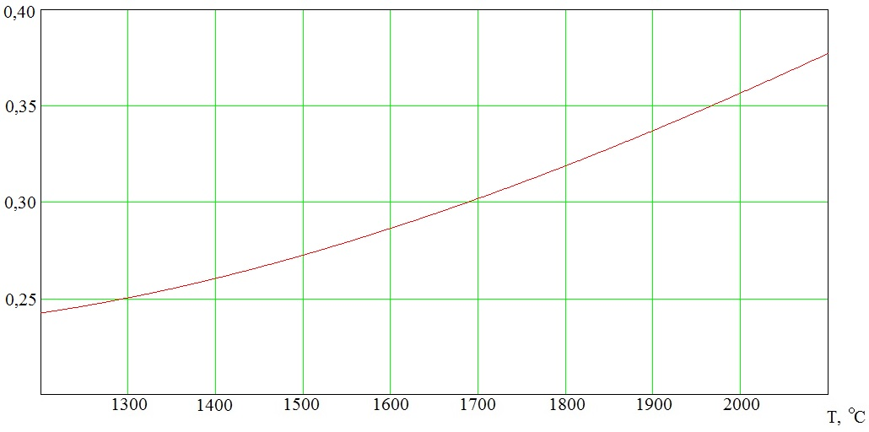
Figure 6. The signals ratio dependence of channels B and R on the temperature with the filter.

Based on the presented results, inference should be drawn that the TCS34725 color sensor can be used as a radiation receiver for a spectral ratio pyrometer with a temperature range of 1200 -
2100 ° C. In this case, the best option is to make a spectral ratio pyrometer using channels G and R with an external filter that cuts off the infrared spectrum part.
5. Conclusion
This solution, in accordance with Table 1, provides the highest radiation receivers use coefficients, and at the same time, the signals ratio dependence of the channels G and R on temperature is monotonically increasing and almost close to linear (Figure 5). These two factors make it possible to simplify the spectral ratio pyrometer electronic scheme implementation.
References
- Valke A A, Lobov D G, Shkaev A G, Shkaev A A and Ponomarev D B 2021 Visual level measurement system application in the technological process automated control system of the recuperative furnace bath, J. of Phys: 1791
- Sun D L, Wang F, Hong R Y and Xie C R 2016 Preparation of carbon black via arc discharge plasma enhanced by thermal pyrolysis Diam. Relat. Mater. 61 pp 21–31
- Zhang Y, Lang X, Hu Z and Shu S 2017 Development of a CCD-based pyrometer for surface temperature measurement of casting billets Measurement Science and Technology 28
- Wang W, Lin J, Zhong W, Zhang B, Xu C and Ding H 2018 Analysis of infrared temperature measurement for flu gas shielding metal surface using source multi-flux method Thermal science 1A 22 pp. 313-321.
- Srsen D Temperature measurement and thermal control of die casting processes using CCD cameras 2012 Electronic Theses and Dissertations 93.
- Tairan F, Huan Z, Jun Z, Zhe W, Maohua Z and Congling S. 2010 Improvements to the three-color optical ccd-based pyrometer system Applied Optics pp. 5997–6005.
- Mendeleev V, Petrov V, Yashin A, Vangonen A and Taganov O 2020 Application of a pyrometer and standard sample to determine the surface temperature of materials under study Measurement Techniques 12 Vol. 62 pp. 1029-34.
- Sun X, Dai J, Cong D and Coppa P 2002 Development of a special multi-wavelength pyrometer for temperature distribution measurements in rocket engines International Journal of Thermophysics 5 Vol. 23 pp. 1293-1301.
- Kropachev D, Grishin A and Maslo A 2012 Real-time methods of measuring the temperature of metallic melts at machine plants. Metallurgist 5-6 Vol. 56 pp. 472-474.
- TCS3472 color light-to-digital converter with IR filter 2012 Reference manual 26

